**HTML5 and CSS3 Training**

**Session1:**

Create a simple profile page with (without css) using HTML5 structural elements like header, nav, article, section, aside, footer etc.

Header

Footer

nav

aside

article/section(with articles)

**It will look something like this:**

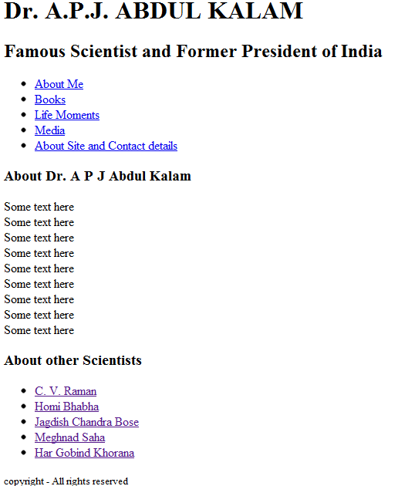

**Session2:**

Add some text in about me sections and use HTML5 text formatting tags wherever applicable.

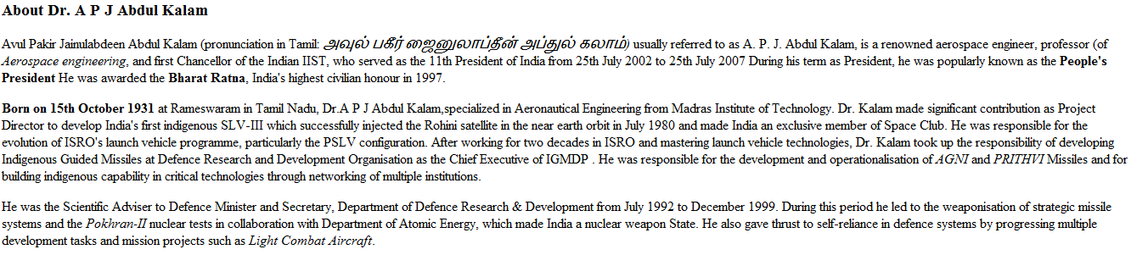

Session3: Understand the basics of CSS3

* Selective styling and working with pseudo classes/elements

Session4: Use CSS Font, Text properties to format text in about me and Header section.

* Add commonproperties.css in the project.

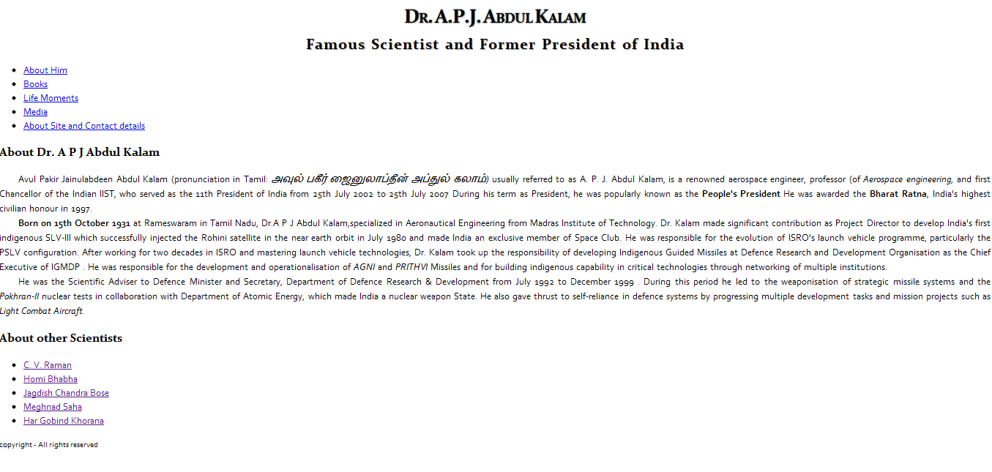

Section5: Use CSS background Properties, color + pseudo classes for links + p:first-letter to change the look and feel of the page as shown below.

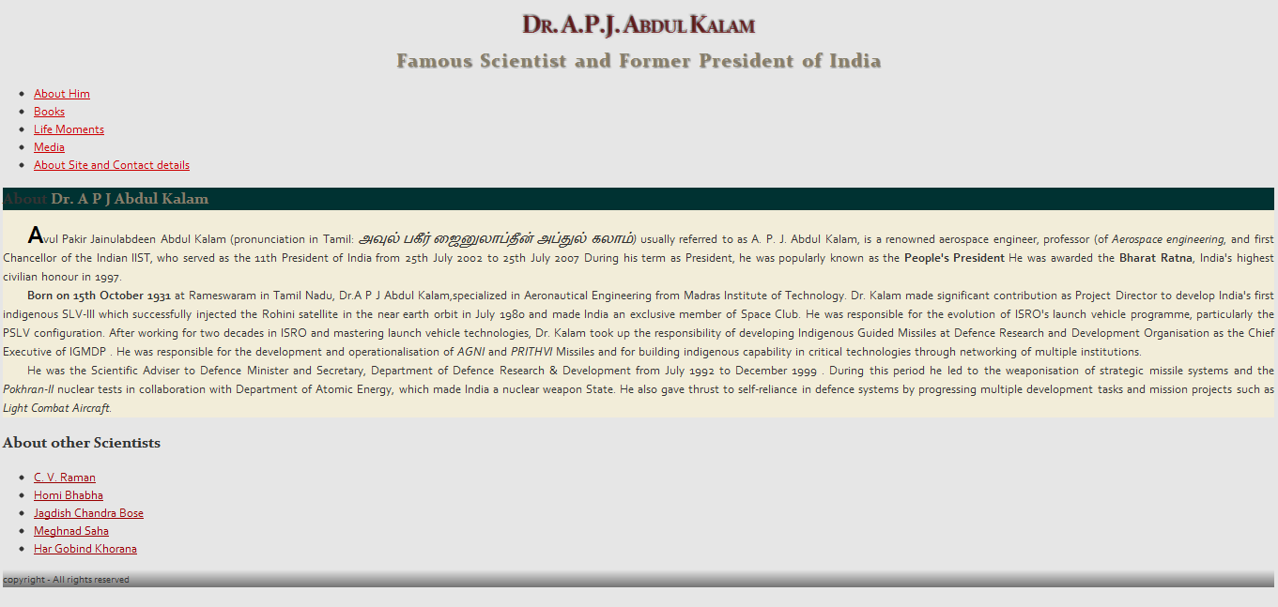

Session6: Use CSS background images and list properties

1. Add custom fonts
2. Add a background image for header
3. Use custom bullets for links

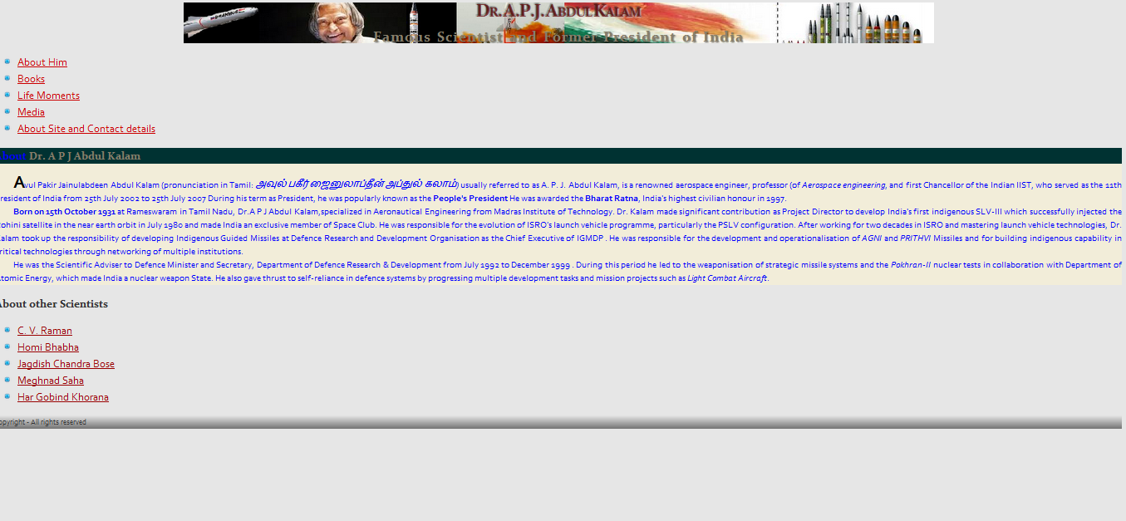

Session7: CSS Table properties

1. Add a table for awards and honors in about me section.
2. Practice table layout and border properties

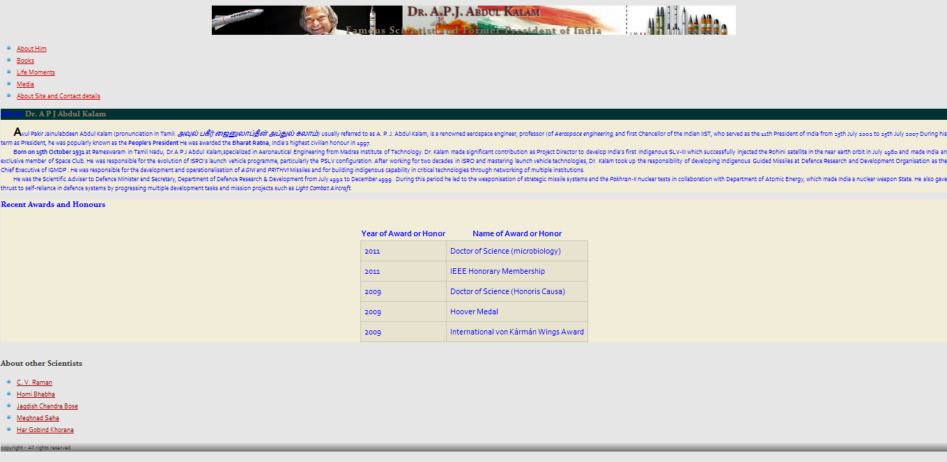

Session8: Understand Box Element in HTML

1. Understand how to layout using floats
2. Create a two column layout with float properties and add a profile pic in aboutMe article as shown below

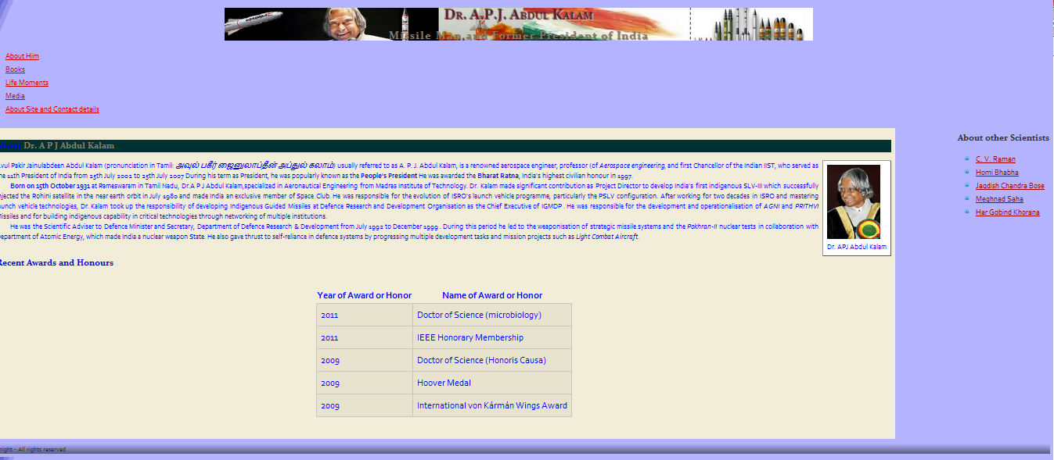

Session9: Understand Display and Box properties

1. Use display property for displaying links horizontally.
2. Also use margins, border and rounded borders corners (new in CSS3*) as shown below.

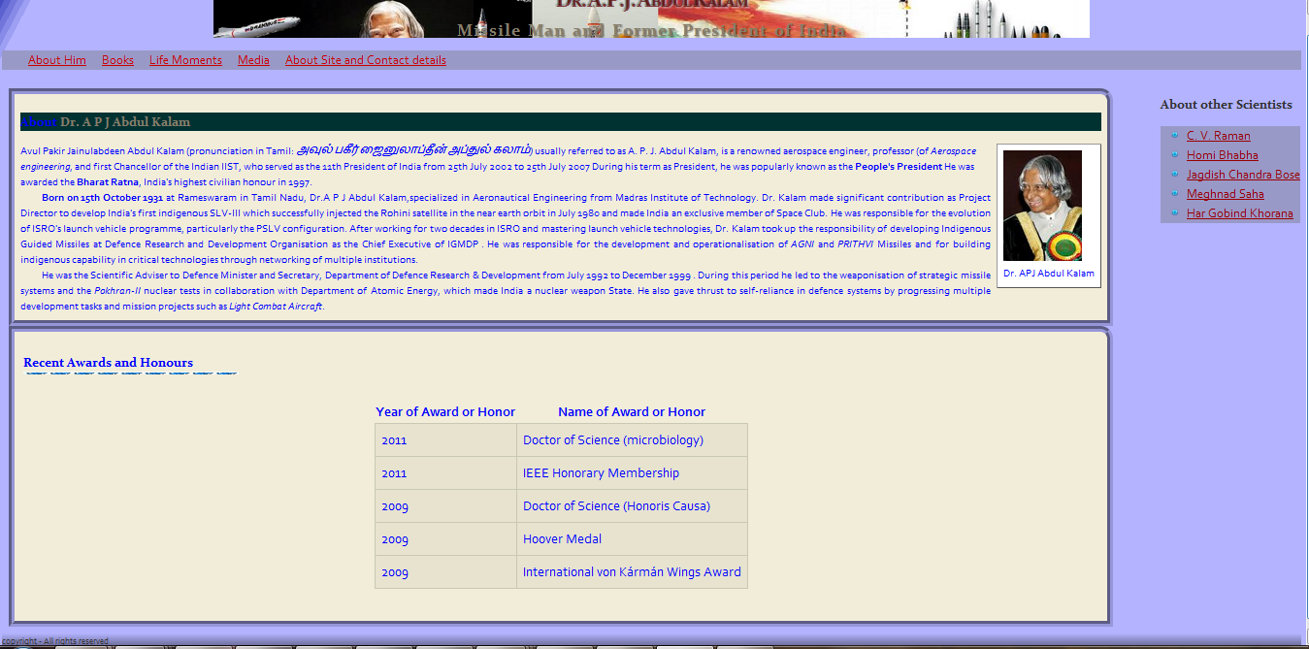

Session10:

Add a new article at the end of the page for Books using CSS floats for layout and HTML5 details and summary elements:

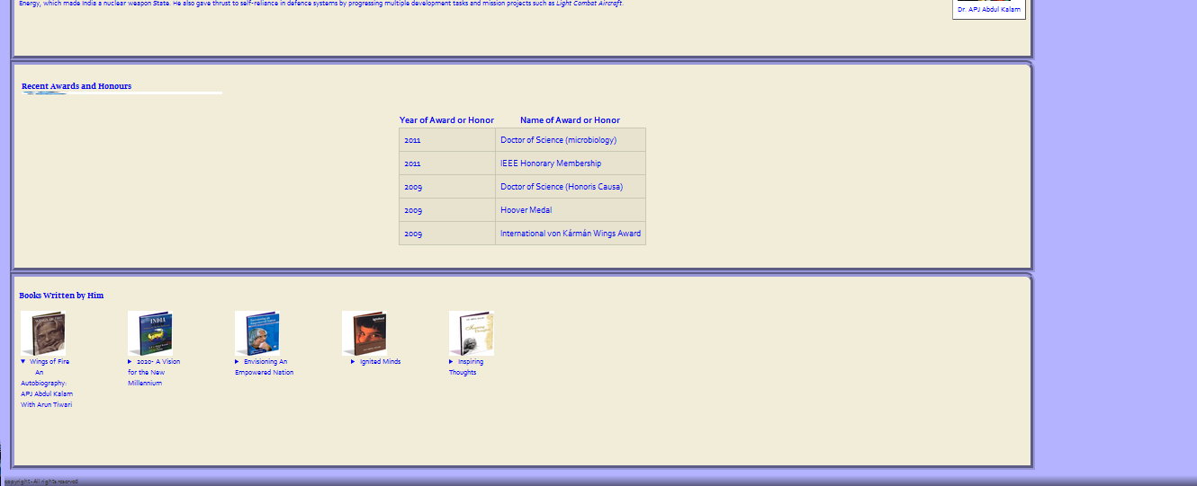

Session 11: CSS3 Transformation and Transition Properties

Add a new article at the end of the page for life moments.

1. Use relative/absolute positioning to place the pics as shown below.
2. Create image shadow and declare opacity and use z-index properties.
3. Use transition/ transformation properties to rotate, scale the images with setting higher value for opacity as soon as mouse is hovered on an image.

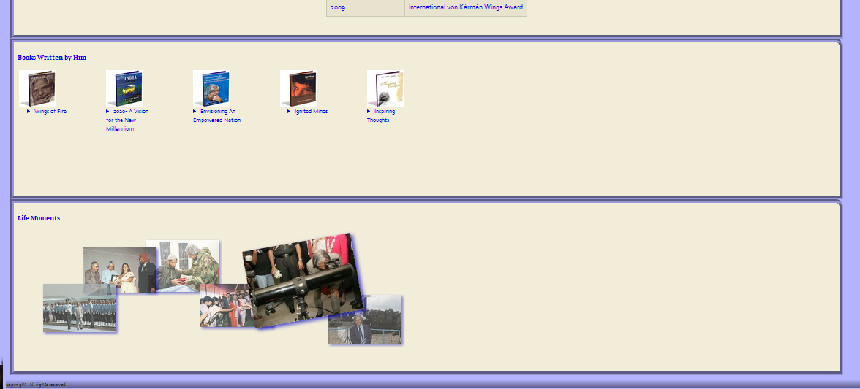

1. Background and borders, opacity, text shadows, pseudo classes

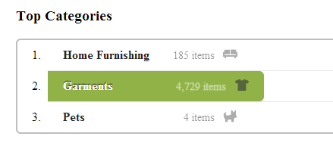

1. Image Transformations, pseudo classes

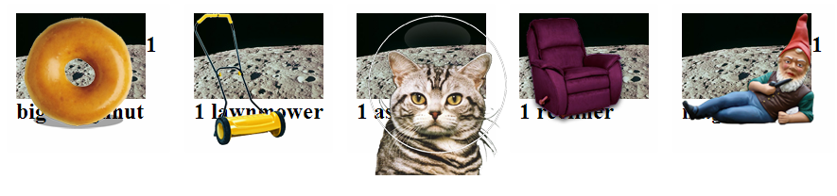

1. Multiple Background images, opacity, rotate transformation, pseudo classes



1. Alignment ,Background, border, pseudo classes



1. Multi column layout

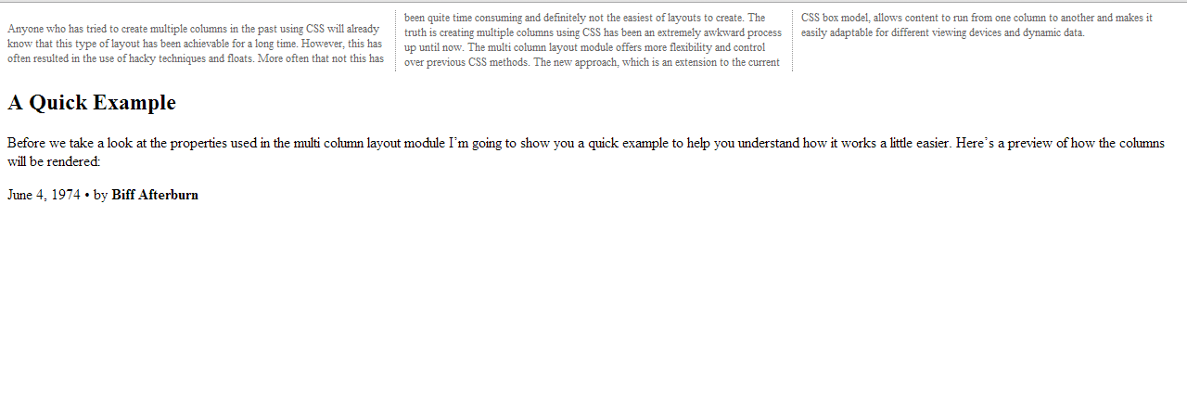

1. Text in Transparent Box

Implement using opacity and background image.

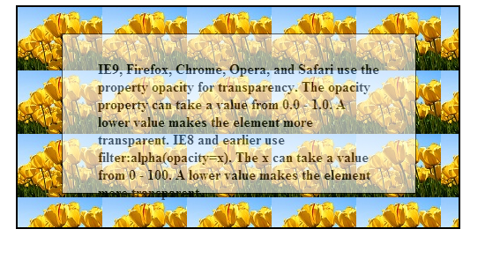

1. On Image Hover

On image hover, it must become transparent.

Implement using opacity.

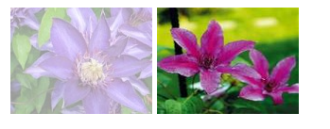

1. Image Gallery

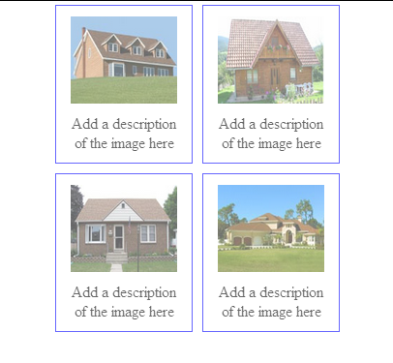

Add a border when image is hovered.

1. Implement using input:focus

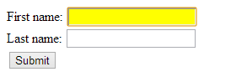

1. Implement using Row collapse. tr.merge{visibility:collapse}

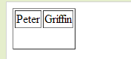

1. Implement a horizontal menu.

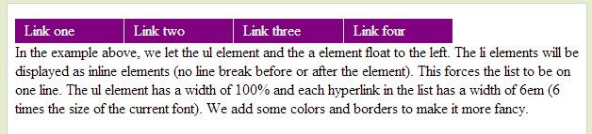

1. Create a home page layout as below.

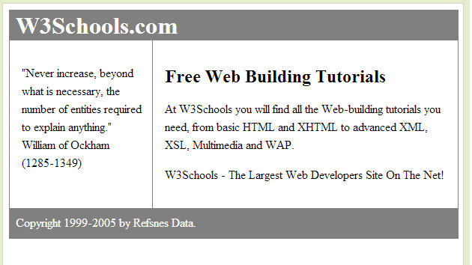

1. Implement using float property.

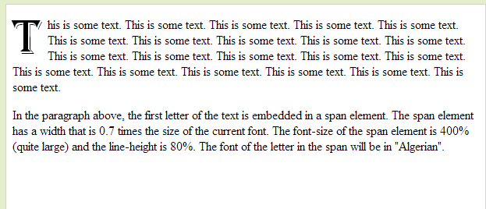

1. Implement a vertical horizontal menu

